Project Design Phase-II
Data Flow Diagram & User Stories

Date | 26-05-2025
Team ID
Project Name | Ecommerce
Maximum Marks | 4 Marks

Data Flow Diagrams:
A Data Flow Diagram (DFD) illustrates how data moves within the E-commerce Platform. It captures how users (shoppers and sellers) interact with the system, how information flows between different components, and where the data is stored.

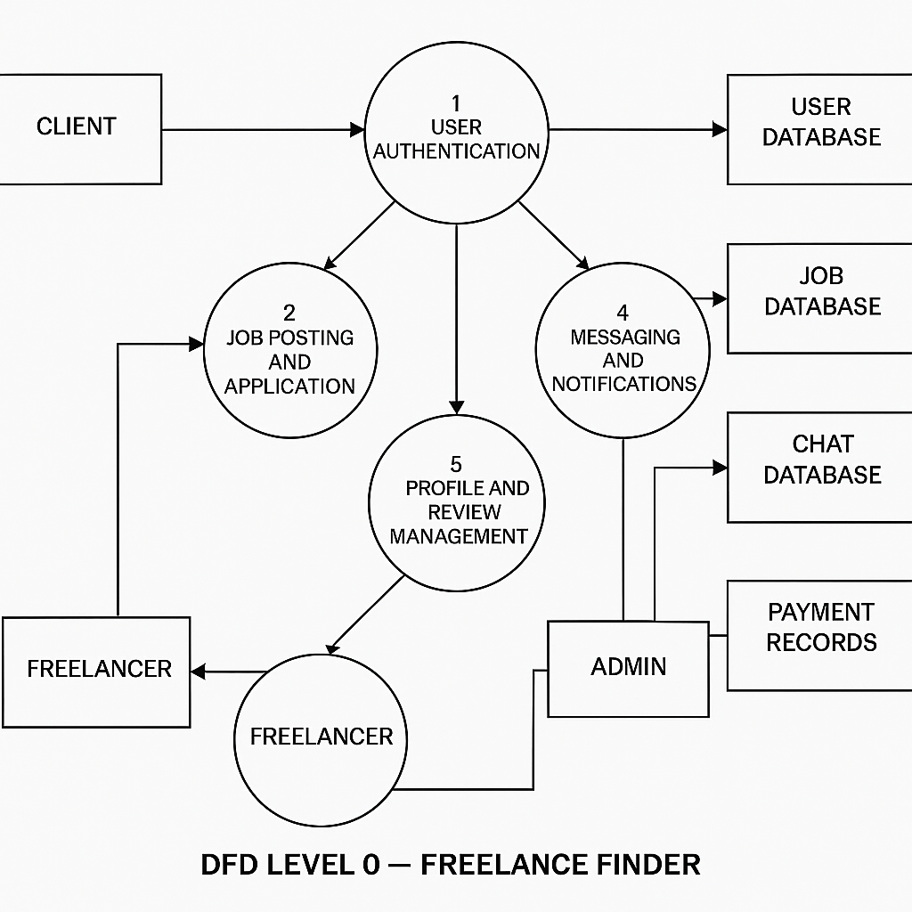

User Stories

User Story Table – Freelance Finder
User Type | Functional Requirement (Epic) | User Story / Task | Acceptance Criteria | Priority | Release
Client |  | As a client, I can post a new freelance job. | Job appears on homepage and my dashboard. | High | Sprint-1
  Job Posting
 |  | As a admin, I can browse and filter available job | Filter returns relevant results. | Medium | Sprint-2
  Job Browsing
ADMIN | Job Application |  | Application visible to client. | High | Sprint-1
  As a drivers, I can apply to a job with a proposal.
User | Messaging | As a user, I can chat with the other party in real-time. | Messages appear instantly. | Medium | Sprint-2
ADMIN | Profile Management | As a flight operators , I can update my profile and portfolio. | Changes are saved successfully. | High | Sprint-2
Client | Payment Processing | As a client, I can make secure payments after job completion. | Payment recorded and shown in transaction history. | High | Sprint-2
user |  | As a user, I can leave a review after project closure. | Review appears on profile. | Medium | Sprint-2
  Review System
Admin | User Moderation | As an admin, I can review reported users and take action. | Reports and actions logged. | High | Sprint-1

